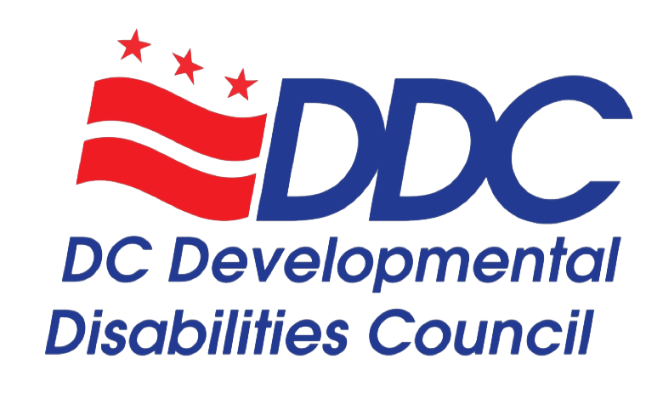
The DC Developmental Disabilities Council (DDC) to Hold Virtual Public Hearings During a 45-Day Public Comment Period for Five Year State Plan
DATE (Washington, DC) - The DC Developmental Disabilities Council (DDC) is proud to announce its Virtual Public Hearings and 45-Day Public Comment Period. The DDC is in the process of developing a new Five-Year State Plan (State Plan) for fiscal years 2022–2026. The State Plan will reflect the diverse voices of the community.
The DDC State Plan’s 2022-2026 main goals are Self-Determination, Advocacy & Leadership, Employment, and Community Living, but it’s not limited to just these areas. Other areas of emphasis include Education, Housing, Health, and Informal Community Support. These goals were chosen after several community forums that were held from November 2020 to February 2021 as well as feedback from a survey that received nearly 250 responses. The draft plan can be found here: https://ddc.dc.gov/page/2022-2026-state-plan
The 45-Day Public Comment Period will begin on May 5, 2021 and end on June 18, 2021. There will be several ways for people to share their feedback with us.
- Attend one of two Virtual Public Hearings on Thursday, May 27, 2021, from 10:00 AM to 11:00 AM and 1:00 PM to 2:00 PM.
- Complete our survey directly. Links to our survey in English, Spanish, Amharic, Korean, Vietnamese, Chinese, and French can be found at: https://ddc.dc.gov/page/2022-2026-state-plan
- Email your comments to: ddcstateplan.comments@dc.gov
- Mail your comments to: Developmental Disabilities Council, 441 4th Street, NW, Suite 729N, Washington, DC 20001
The Developmental Disabilities Council of the District of Columbia seeks to strengthen the voice of people with developmental disabilities and their families in DC in support of greater independence, inclusion, empowerment, and the pursuit of life as they choose. We strive to create change that eliminates discrimination and removes barriers to full inclusion through our advocacy.
The DDC is established and operates by the Developmental Disabilities Assistance and Bill of Rights Act of 2000 -Public Law 106-402. In accordance with the DD Act, the DC Developmental Disabilities Council is required to develop and implement a Five Year State Plan. The Five Year State Plan identifies the most pressing needs of people with developmental disabilities in the District of Columbia. The DDC addresses these needs through systems change, advocacy, and capacity building efforts that promote self-determination, integration, and inclusion for people with developmental disabilities.
For more information, visit our website at https://ddc.dc.gov/page/2022-2026-state-plan or email Alison Whyte, Executive Director, at alison.whyte@dc.gov or call/text 202-340-8563.

