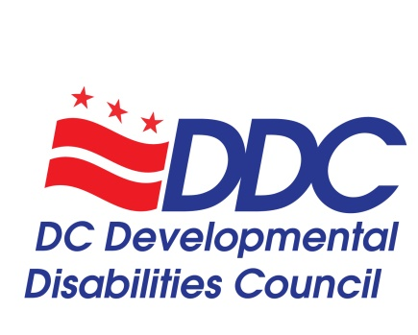

Public Meeting Agenda
Thursday, November 21, 2019, 3-5pm
441 4th St. NW, Room 1114
Washington, DC 20001
Conference Line: 866-624-8591, Code: 2413505#

Topic | Time | Facilitator
Welcome and Call to Order | 3:00-3:05 | Carol Grigsby
Introductions of Councilmembers and DDC Staff | 3:05-3:10 | Carol Grigsby
Introductions of Public Guests | 3:10-3:15 | Carol Grigsby
Old Business (August Minutes) | 3:15-3:20 | Ricardo Thornton
Committee Updates  - Public Policy and Advocacy  - State Plan | 3:20-3:30 | Carol Grigsby and Lisa Matthews
DDC State Plan Discussion  - Dashboard Review  - Final Reports on FY19 Programs  - Overview of FY20 Programs | 3:30-3:40 | Alison Whyte
Presentation: Working Group on Healthy Relationships and Sex Education | 3:40-3:55 | Molly Whalen and Sarah Grime
Executive Director’s Report  - Membership Update – New Members and Reappointments  - Staffing Update  - Marketing Materials Updates  - NACDD Oral History Project  - Innovation Grants Review Committee | 3:55-4:05 | Alison Whyte
Presentation: Connecting with our Neighbor to the North - Maryland DD Council | 4:05-4:20 | Rachel London
Public Comments or Questions | 4:20-4:25 | Carol Grigsby
Updates from DD Council Organizational Representatives  - DD Act Triad – Disability Rights DC at University Legal Services and Georgetown University Center for Excellence in Developmental Disabilities  - Department on Aging and Community Living  - DC Department on Disability Services  - SchoolTalk  - Project ACTION!  - Mayor’s Commission on Persons with Disabilities  - Family Support Council | 4:25-4:40 | Organization Representatives
DDC Budget Update  - FY20 Budget Review | 4:40-4:45 | Alison Whyte
Discussion of January 2020 DDC Retreat  - Date and Location Announced  - Overview of Agenda – Bylaws, Ethics, DD Act Requirements, and more! | 4:45-4:50 | Alison Whyte and Carol Grigsby
Public Comments & Community Announcements | 4:50-4:55 | Carol Grigsby
Conclusion and Adjournment | 4:55-5:00 | Carol Grigsby

DD Council Staff
Alison Whyte, Executive Director
Denise McCain, Administrative Assistant
Shakeitha Stone, Aspiring Professionals Intern
Jivon Jackson, Aspiring Professionals Intern

DD Council Executive Committee
Carol Grigsby, DDC Chairperson and Public Policy and Advocacy Committee Chairperson
Ricardo Thornton, DDC Vice-Chairperson
Lisa Matthews, State Plan Implementation Committee Chairperson

Next Public Meeting – Thursday, March 19, 2020, 3-5pm

