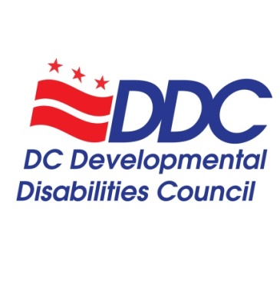

Special Meeting Agenda
Thursday, September 29, 2022, 3-4 pm

Members in Attendance
- Andy Reese, Representative of the Department on Disability Services, (Represented by Proxy, Crystal Thomas)
- Anjie Shelby, DDC Chairperson, Community Representative
- Berta Mata, Representative of a local non-governmental organization, Advocates for Justice and Education
- Carol Grigsby, Advocacy and Public Policy Committee Co-Chair, Community Representative
- Cheri Mallory, Community Representative
- Derrick Simms, Community Representative
- Jane Brown, State Plan Committee Chair, Representative of Disability Rights DC, Protection and Advocacy Agency
- Laraven Gaymon, Community Representative
- Stephanie Lanham, Community Representative
- Tawara Goode, Representative of the Georgetown University Center for Excellence in Developmental Disabilities (Represented by Proxy, Robin Shaffert)
- Yetta Myrick, Community Representative
- Zoe Gross, Community Representative

Excused or Absent Members
- Bernard Crawford, Community Representative
- Elisa Peña Zavala, Community Representative
- Montezz Green, Community Representative
- Naisha Dembele, Representative of a local non-profit organization, SchoolTalk DC
- Ricardo Thornton, DDC Vice-Chair, Advocacy and Public Policy Committee Co-Chair, Community Representative
- Uchenna Egenti, Community Representative

Staff
- Alison Whyte, Executive Director
- Carla McCaskill, Program Support Specialist
- Kevin Wright, Program Support Assistant
- Luz Collazo, Program Analyst

Topic | Minutes
Welcome and Call to Order | This was a special meeting held to vote on items that were held over from the 9/15/22 meeting due to lack of quorum. Anjie Shelby, DDC, called the meeting to order at
FY23 Budget (Vote Required) | Alison Whyte shared the FY23 Proposed Budget. Zoe Gross motioned to approve the budget. Yetta Myrick seconded the motion. Votes are in the table below.
Bylaws, Stipend Policy, and Anti-Racism Statement (Vote Required) | Additional changes were requested in the bylaws, stipend policy, and anti-racism statement. These requested changes will be made for the December 2022 public meeting.
Position Papers (Vote Required)  - Employment  - Policing | The Employment Position paper was presented first. Carol Grigsby motioned the approve the paper. Robin Shaffer seconded the motion. Votes are in the table below.  The Policing Position Paper was discussed, and additional changes were requested. By this time in the meeting, some Councilmembers had to leave, and there was no longer a quorum for a vote. This paper will be presented again at the December 2022 meeting.
June 16, 2022 Minutes (Vote Required) | There was no longer a quorum to vote on this item in this meeting. It will be held until December 2022 for a vote.
Conclusion and Adjournment | The meeting adjourned at 4 pm

Councilmembers | FY23 Budget | Employment Position Paper
Andy Reese (Crystal Thomas proxy) | Abstain | Aye
Anjie Shelby | Aye | Aye
Bernard Crawford | Absent | Absent
Berta Mata | Aye | Aye
Carol Grigsby | Aye | Aye
Cheri Mallory | Aye | Aye
Derrick Simms | Aye | Aye
Elisa Peña Zavala | Absent | Absent
Jane Brown | Aye | Aye
Laraven Gaymon | Aye | Aye
Montezz Green | Absent | Absent
Naisha Dembele | Absent | Absent
Ricardo Thornton | Absent | Absent
Stephanie Lanham | Aye | Abstain
Tawara Goode (Robin Shaffert) | Aye | Aye
Uchenna Egenti | Absent | Absent
Yetta Myrick | Aye | Aye
Zoe Gross | Aye | Aye

