Things to do during COVID-19

Free films and other entertainment
- Sproutflix is offering 10 popular short films, featuring people with intellectual and developmental disabilities, for free right now! Click this link to see the playlist - http://sproutflix.org/virtual-sprout-film-festival/
- Metropolitan Opera is offering free streaming of one opera every day during the coronavirus closure, released on their homepage every night at 7:30pm - https://www.metopera.org/
- DC Public Library Go Digital – tons of free books, movies, and music - https://www.dclibrary.org/godigital
- Audible is offering free titles for listeners 0-18 in English, Spanish, German, French, Japanese and Italian - www.stories.audible.com
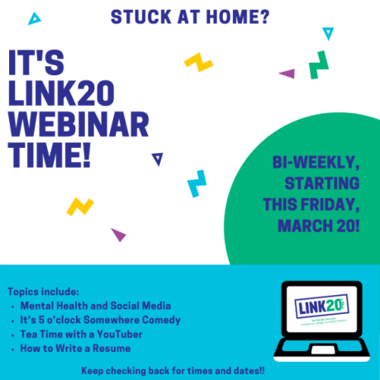
- #operationASLstorytime - Stories in ASL! https://www.youtube.com/playlist?list=PLyyNOvCkEYaF_eS-zb4nHES6W4ZkNPHck

Virtual social connection
- LINK20 Webinars are here! Webinars twice a week for the coming weeks! The first one is this Friday, March 20 at 2pm EST. RSVP to Jenny@rudermanfoundation.org to let us know that you are coming!! Zoom Meeting: https://zoom.us/j/975069493; Meeting ID: 975 069 493
- Two months of free internet for new customers - https://internetessentials.com/?fbclid=IwAR0BnafiiPhY7wUFnw8MBLXK6Gwr_NMMzHGxSQkkqfLxETkVQd0G3bdd1cY
- Virtual dinner parties hosted on Zoom by The Table Church - https://thetablechurchdc.org/dinnerparties
- Virtual church services are being offered by many churches:
- The Table Church, 5pm Sundays - https://thetablechurch.online.church/
- Capital Life Church, 10:30am Sundays - https://capitallife.org/covid-19-coronavirus-update/
- Metro Church - https://metrochurch.com/watch/
- The Community Church of Washington DC, various times for prayer calls and virtual services - https://www.facebook.com/pg/www.ccwdc.org/events/?ref=page_internal
- National Presbyterian Church, 11am Sundays - http://nationalpres.org/live
- Waterfront Church DC, many different online resources - https://www.waterfrontchurchdc.com/livestream
- Chinese Community Church, alternate remote worship options - http://www.cccdc.com/2020/03/20/worship-at-home-march-22-2020/
- Long list of live streamed Catholic masses and prayers in DC - https://adw.org/live-streamed-masses-and-prayers/

Physical activity
- Lots of great activity ideas at this website - https://theimaginationtree.com/stay-at-home-survival-guide/
- Yoga with Adriene – lots of free yoga videos, including chair yoga and meditation! https://www.youtube.com/channel/UCFKE7WVJfvaHW5q283SxchA
- Special Olympics’ School of Strength videos - https://www.specialolympics.org/school-of-strength?utm_medium=email&utm_source=specialolymp&utm_content=3+-+Check+out+the+videos+Fitness+Tracker+and&utm_campaign=20200320_schoolofstrengthe1b&source=20200320_schoolofstrengthe1b&ms=20200320_schoolofstrengthe1b&cha=12
- Headspace is offering free meditations - https://www.headspace.com/covid-19

Food and nutrition
- DC Public Schools has pick-up sites Monday-Friday for school age children to receive a free lunch - https://coronavirus.dc.gov/sites/default/files/dc/sites/coronavirus/publication/attachments/Meal%20Sites03192020%40930am.pdf
- Capital Area Food Bank is offering ongoing food distribution to people’s homes through partner organizations and community hub locations for food pick up. The best way to stay informed about these is to visit their website - https://www.capitalareafoodbank.org/covid19response/ or call their hunger lifeline - 202-644-9807

Learning activities
- DC Public Schools has their distance learning website up and running where you can access learning activities and lessons - https://dcps.instructure.com/courses/179580
- Free class offered by Yale called The Science of Wellbeing - https://www.coursera.org/learn/the-science-of-well-being

Requests for help
- COVID-19 Neighborhood Need Request – register a request for support here: https://docs.google.com/forms/d/e/1FAIpQLSfI1gz0iFfpIOs12kZT8xrreddmoSPtiDn_bT-vjLns_WuO0g/viewform
- DC Mutual Aid Network for Wards 7&8 – call to report your need for childcare, groceries, translators, hygiene products, etc. – 202-630-0336
- DC Mutual Aid Network for Ward 5 – call to report your need for childcare, groceries, translators, hygiene products, etc. – https://docs.google.com/forms/d/e/1FAIpQLScoHwezDrIhbEhQsSr_QbgSbOyq2ZJtsNCsYkNc5Y33C4n2Sw/viewform
- Nextdoor neighborhood lists – many neighbors are offering up support for anyone who needs it. This is a great place to post a need that you have and get help from a neighbor – https://nextdoor.com or on the app

