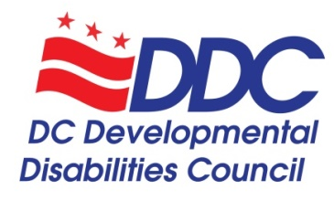

Public Meeting Agenda
Thursday, September 24, 2020, 3-5pm

Topic | Time | Facilitator
Welcome and Call to Order | 3:00-3:05 | Carol Grigsby
Explanation of Virtual Platform and Accessibility | 3:05-3:10 | Alison Whyte
Introduction of Councilmembers and DDC Staff  - Special welcome to Emily Kranking! | 3:10-3:15 | Carol Grigsby
Introduction of Members of the Public | 3:15-3:20 | Carol Grigsby
Council Business Votes  - June Minutes  - FY21 Budget  - DD Council Bylaws | 3:20-3:35 | Ricardo Thornton
Moving from Crisis Operations to New Normal | 3:35-3:40 | Carol Grigsby
Current State Plan Progress and Future State Planning | 3:40-3:50 | Alison Whyte
Public Comments | 3:50-4:00 | Carol Grigsby
Presentation: Best Buddies of the Capital Region | 4:00-4:15 | Molly Whalen
DD Council Staff Report  - Membership recruitment  - DDC Statement on Anti-Racism and Commitments  - Latinx Conference on Disabilities  - Disability Community and Policing Working Group  - Census 2020 and 2020 Election | 4:15-4:30 | Alison Whyte
DD Council Organizational Representatives Updates  - DD Network – Disability Rights DC at University Legal Services and Georgetown University Center for Excellence in Developmental Disabilities  - SchoolTalk  - Project ACTION!  - Mayor’s Commission on Persons with Disabilities  - Family Support Council  - Department on Disability Services (DDS)  - Department on Aging and Community Living (DACL) | 4:30-4:50 | Organization Representatives
Public Comments & Community Announcements | 4:50-5:00 | Carol Grigsby
Conclusion and Adjournment | 5:00 | Carol Grigsby

DD Council Staff
Alison Whyte, Executive Director
Luz Collazo, Program and Policy Analyst
Denise McCain, Administrative Assistant
Emily Kranking, Strategic Communications Fellow

DD Council COVID-19 Crisis Committee
Carol Grigsby, Chair - DDC and Policy Committee
Ricardo Thornton, DDC Vice-Chairperson
Lisa Matthews, chair, State Plan committee
Kali Wasenko*
Tawara Goode*
Yetta Myrick*
Anjie Shelby*

