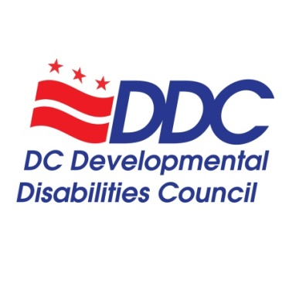

Quarterly Public Meeting Agenda
Thursday, June 16, 2022, 3-5 pm
Advance registration requested: https://us06web.zoom.us/meeting/register/tZcqf-iqrzspG9LMXkgr3WUbGCoQ3lyp9nCJ
In-person (vaccination and masks required): 441 4th Street NW, Room 1114 (11th Floor South)

Topic | Time | Facilitator
Welcome and Call to Order | 3-3:05 | Anjie Shelby, Chair
Explanation of Virtual Platform and Accessibility | 3:05-3:10 | Alison Whyte, Exec. Dir.
Introduction of Councilmembers and DDC Staff | 3:10-3:20 | Anjie Shelby, Chair
Council Business Votes  - March 17, 2022 Minutes | 3:20-3:25 | Ricardo Thornton
Chairperson Remarks  - Call for Ad-Hoc Committee to begin Bylaws, Stipend Policy, and Anti-Racism Statement review and updates  - DDC Summer Social  - Update from the Commission on Persons with Disabilities  - Councilmembers Roles and Responsibilities | 3:25-3:35 | Anjie Shelby, Chair
State Plan Committee Updates  - FY22-26 State Plan Progress and Activities | 3:35-3:45 | Jane Brown
Advocacy and Public Policy Committee Updates  - FY23 Budget Update  - Position Papers  - Update on DD Eligibility  - Vaccine and booster encouragement | 3:45-3:55 | Ricardo Thornton, Carol Grigsby
Public Comments and Questions | 3:55-4:05 | Anjie Shelby
Employment First Summit  October 20-21, 2022 | 4:05-4:20 | Kevin Wright, Alison Whyte
DD Council Executive Director Report  - Bridging Aging and Disability Networks Grant  - Staff updates  - Councilmember Terms and Changes  - Bios and Photos from Councilmembers  - June 21, 2022 Primary Election - Voting Resources  - FY22 Budget Update | 4:20-4:25 | Alison Whyte
DD Council Organizational Representatives Updates  - DD Network – Disability Rights DC at University Legal Services and Georgetown University Center for Excellence in Developmental Disabilities  - SchoolTalk DC  - Advocates for Justice and Education (AJE)  - Department on Disability Services (DDS)  - Department on Aging and Community Living (DACL)  - Project ACTION! | 4:25-4:45 | Organization Representatives
Public Comments & Community Announcements | 4:45-4:55 | Anjie Shelby
Conclusion and Adjournment | 4:55-5 | Anjie Shelby

DD Council Staff
Alison Whyte, Executive Director
Erin Olson, 2022 Summer Intern
Kevin Wright, Employment and Advocacy Strategies Fellow
Luz Collazo, Program Analyst

DD Council Leadership
Anjie Shelby, DDC Chairperson
Ricardo Thornton, DDC Vice-Chair, Advocacy and Public Policy Committee Co-Chair
Carol Grigsby, Advocacy and Public Policy Committee Co-Chair
Jane Brown, State Plan Committee Chair

DD Councilmembers and Affiliations (if not appointed as a community member)
- Andrew Reese, DC Department on Disability Services (Rehabilitation Act)
- Anjie Shelby
- Bernard Crawford
- Berta Mata, Advocates for Justice and Education
- Carol Grigsby
- Cheri Mallory
- Dari Pogach (not formally appointed), Department on Aging and Community Living (Older Americans Act)
- Derrick Simms
- Elisa Pena Zavala
- Jane Brown, DD Network: Disability Rights DC (Protection and Advocacy Agency)
- Laraven Gaymon
- Montezz Green
- Naisha Dembele, SchoolTalk DC
- Ricardo Thornton
- Stephanie Lanham
- Tawara Goode, DD Network: Georgetown University Center for Excellence in Developmental Disabilities
- Uchenna Egenti
- Yetta Myrick
- Zoe Gross
- Vacant, People with DD or Family Members
- Vacant, DC Health (Title V - Maternal and Child Health Program)
- Vacant, Department of Healthcare Finance (Title XIX of Social Security Act)
- Vacant, Office of the State Superintendent of Education (IDEA)

2022 DD Council Public Meeting Dates
3rd Thursday of the month, every 3 months, 3-5pm
- March 17
- June 16
- September 15
- December 15

