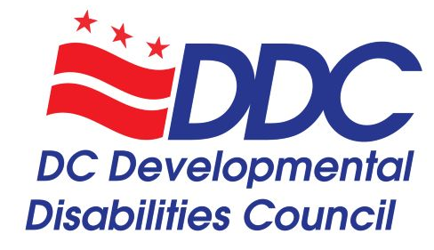

Event:
DC Developmental Disabilities Council Public Meeting

Date and time:
Thursday, June 18, 2020 3:00 pm (Eastern Daylight Time). Attendees may join the meeting any time after 2:30pm and we will start at 3pm.

Link to join the event from your computer or tablet:
https://dcnet.webex.com/dcnet/onstage/g.php?MTID=e056740d72c824e98bf38a785db40d7c4
You must enter your name, email address, and the event password – DDC2020. Once you join the meeting, you may choose to use your computer’s audio, or to call in to the meeting on your phone. To receive a call back, provide your phone number when you join the event, or call the number below and enter the access code.

Event password:
DDC2020

How to join the event by phone:
Dial 202-860-2110 and enter access code: 160 384 2688

Accessibility for the meeting:
We will have ASL interpreters as well as CART (Communication Access Realtime Translation) throughout the meeting. The captions will show up in the bottom right corner of the Webex screen in the Multimedia Viewer box. We will be recording the meeting and posting the video recording and transcription on our website afterwards. On the Webex Events screen, we will have a PowerPoint presentation that will mirror the agenda and include presentations from the Office of Planning and the Office of Disability Rights (see agenda for details). We are aware that the screen share feature on Webex is not accessible to screen readers, so we will describe everything on the screen and the PowerPoint will be posted on our website for anyone to open on their own device and follow along.

All attendees will be muted upon entry and will not be able to show video. If you are joining on your computer or tablet, you will be able to see video of any speakers, ASL interpreters, and/or the appointed DD Council members and staff. Attendees will be unmuted during public comment periods and during this time, please be proactive about muting yourself on your own device if you are not speaking. Attendees may ask questions or make comments the question and answer box throughout the meeting or by texting your question to 202-340-8563. If you need video access in order to make public comments in ASL, please email alison.whyte@dc.gov or text 202-340-8563.

System requirements for joining the meeting on your computer or tablet:
https://help.webex.com/en-us/nki3xrq/Webex-Meetings-Suite-System-Requirements

Meeting materials:
All materials are posted on our website here: https://ddc.dc.gov/page/dd-council-meetings
- Agenda
- Meeting PowerPoint Presentation
- Minutes from April Meeting
- Notes from January’s retreat
- Bylaws – Draft to present at 6/18/20 meeting
- Georgetown UCEDD Transition Partnership Abstract
- Census and voting resources

